Perform password auditing and cracking using L0phtCrack to assess the strength of passwords. Emphasize the importance of strong password policies.

Step1. Search l0phtcrack in the search field, click Open to launch it
Step2: L0phtCrack 7 window appears, click the Password Auditing Wizard button.
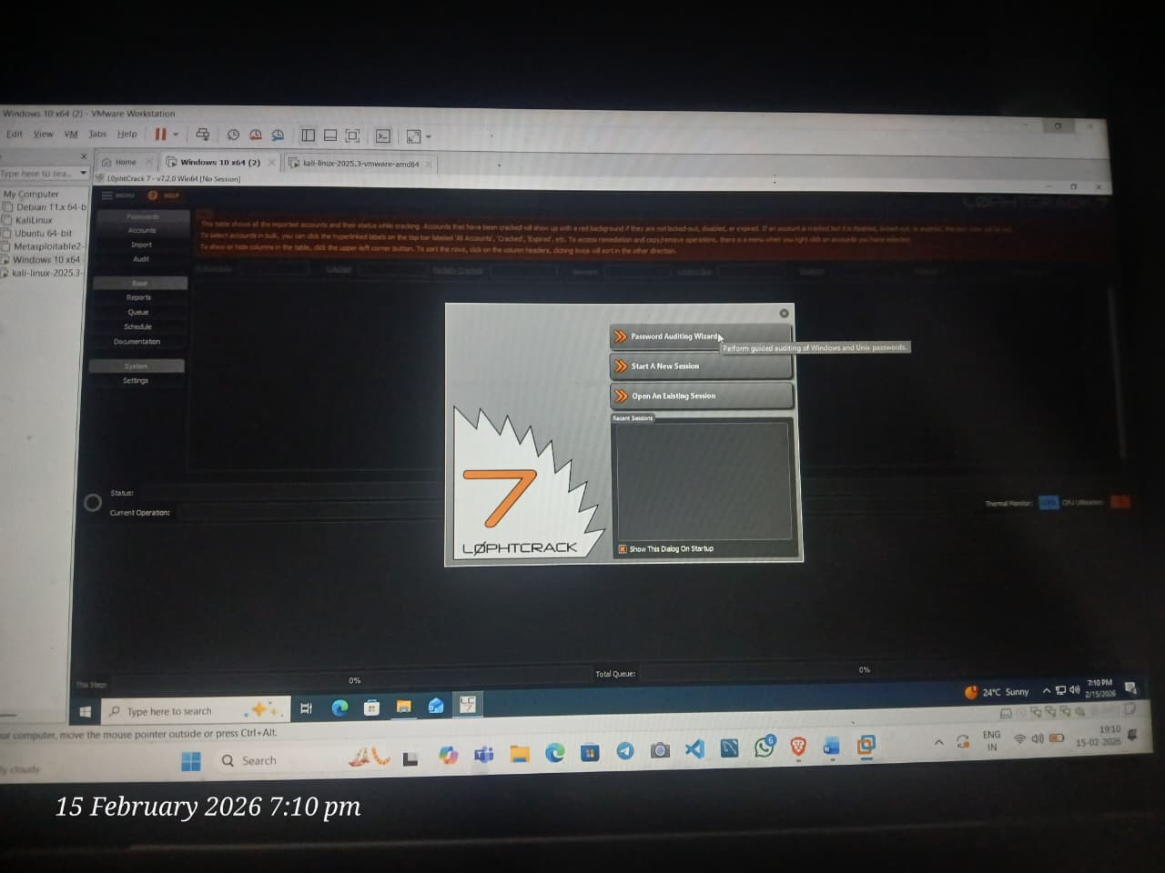
Step4: The LC7 Password Auditing Wizard window appears; click Next.
Step5: In the Choose Target System Type wizard, ensure that the Windows radio button is selected and click Next
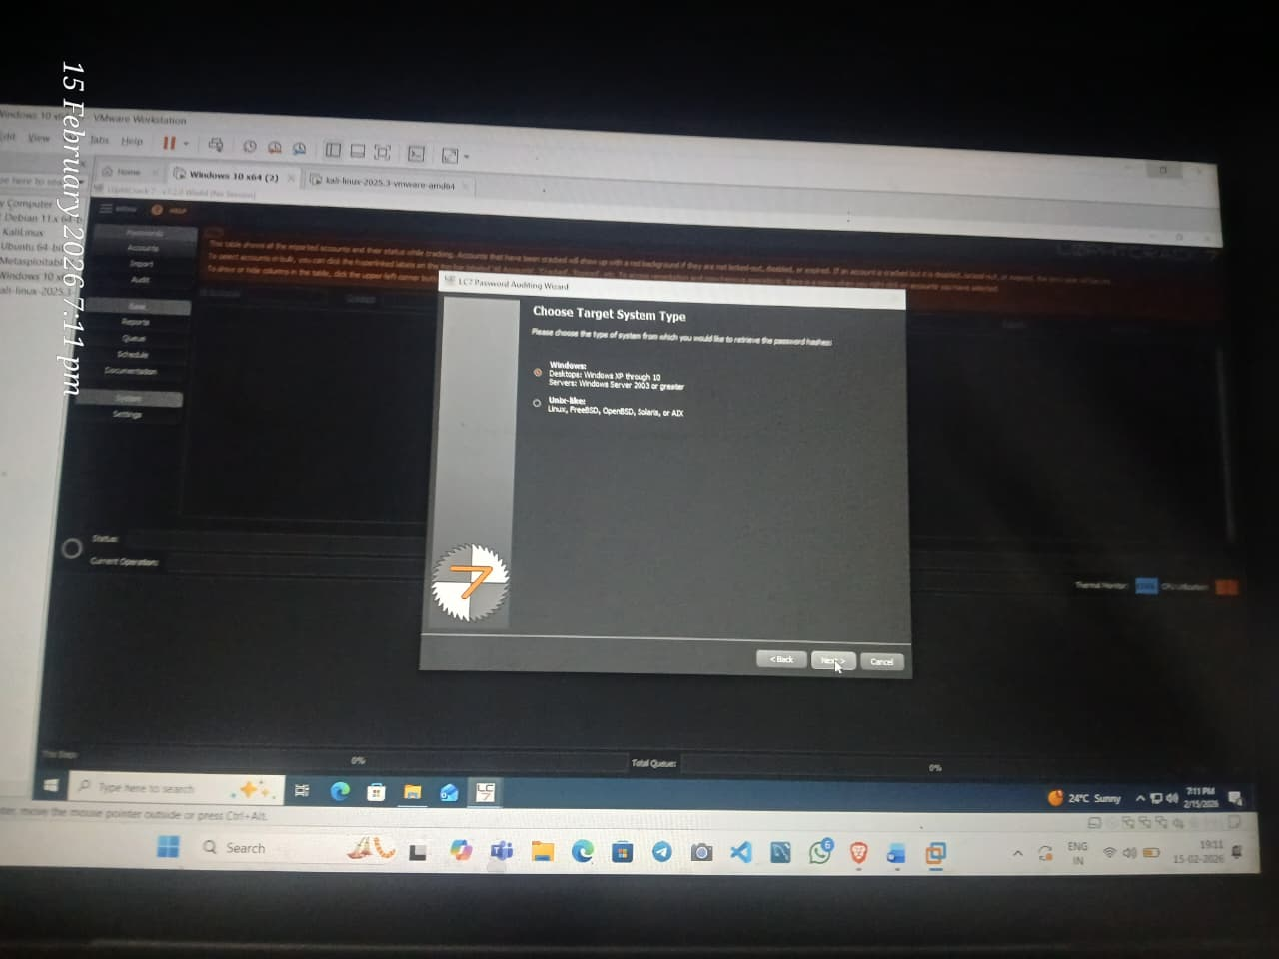

Step 6: In the Windows Import wizard, select the button local machine and click Next.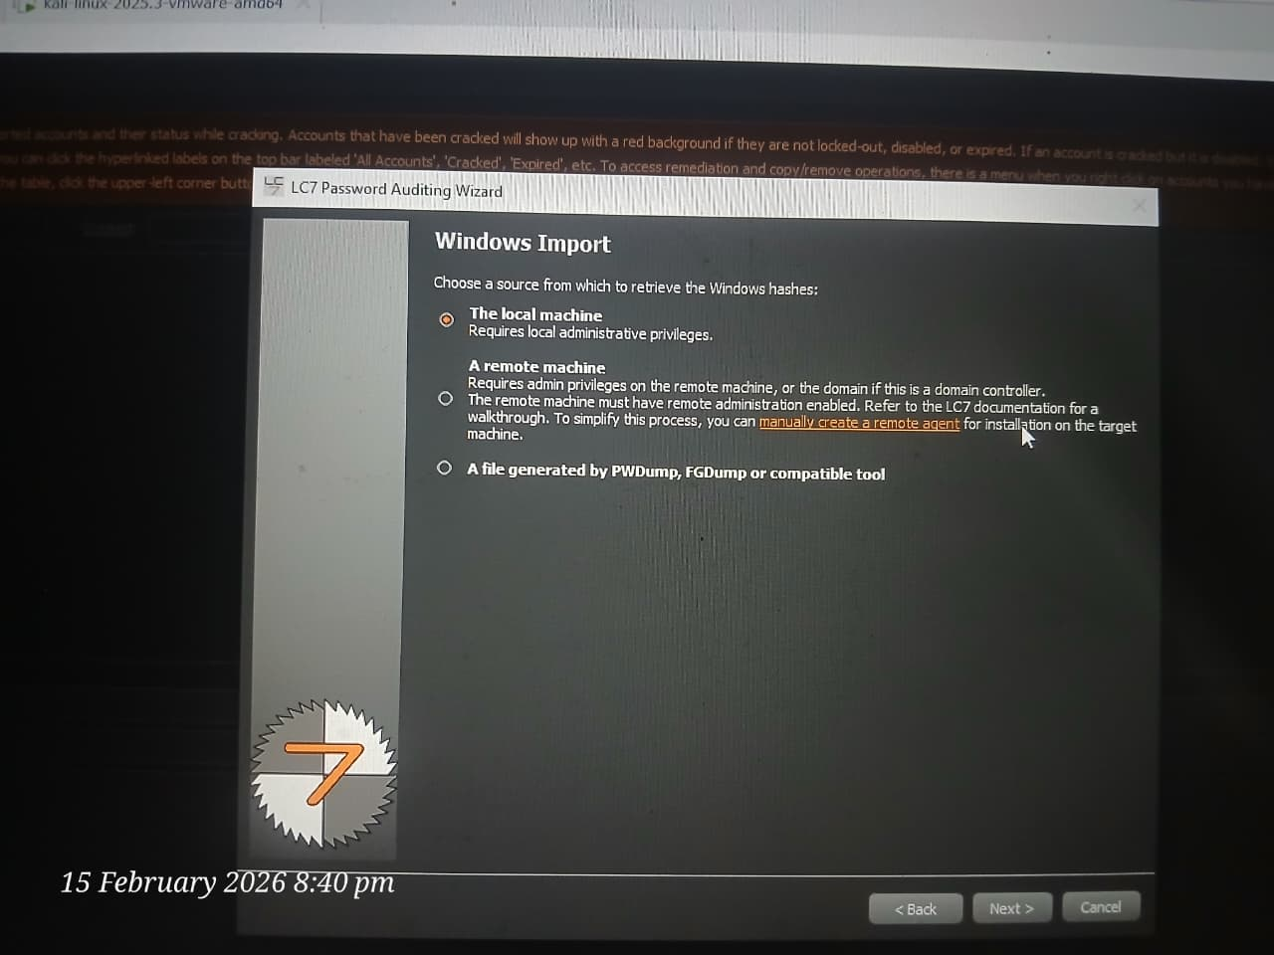
STEP6:CHOOSE THE AUDIT TYPE AS “QIUCK PASSWORD AUDIT”
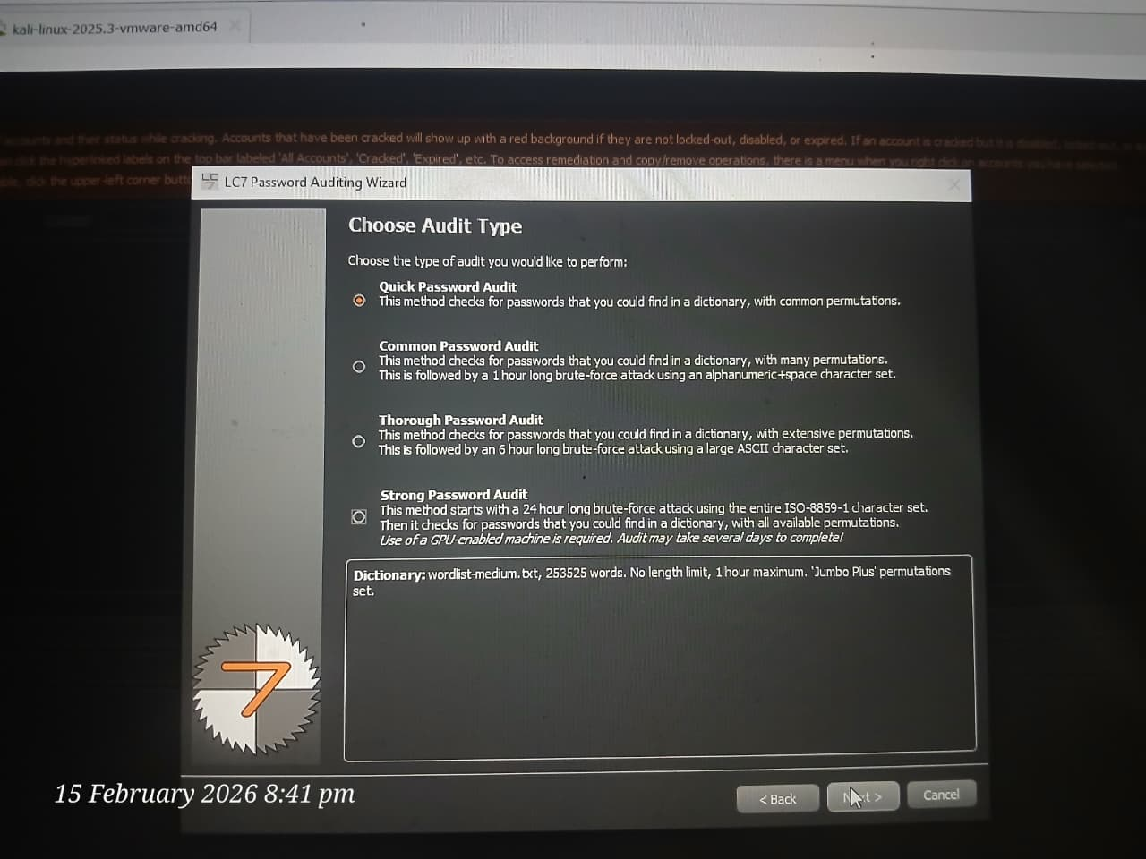

STEP7: In the Reporting Options wizard, select the Generate Report at End of Auditing option and ensure that the HTML report type radio button is selected. Click the Browse… button to store the report in the desired location.
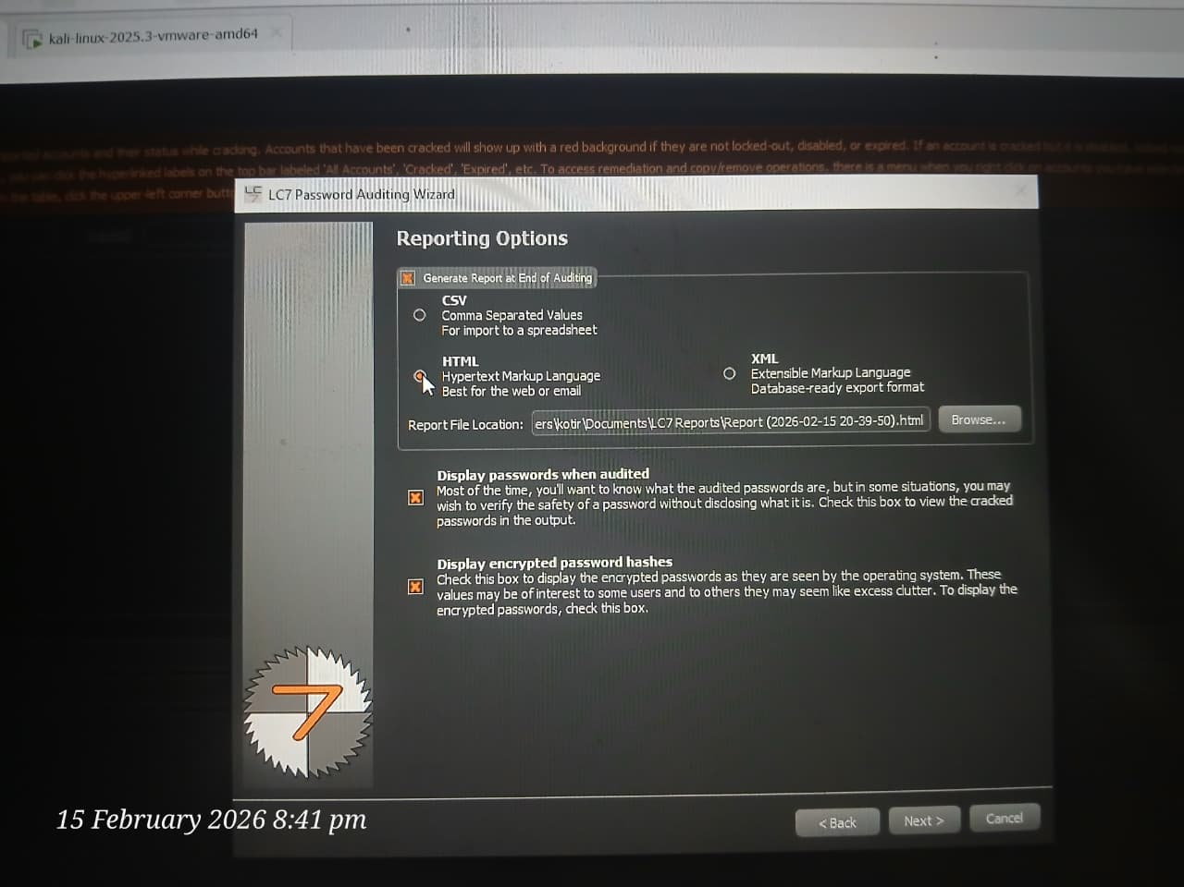

STEP 08:
The Choose report file name window appears; select the desired location (here, Desktop) and click Save.
Step 09: In the Reporting Options wizard, the selected location to save the file appears under the Report File Location field; click Next.
Step10:The Job Scheduling wizard appears. Ensure that the Run this job immediately radio button is selected and click Next.

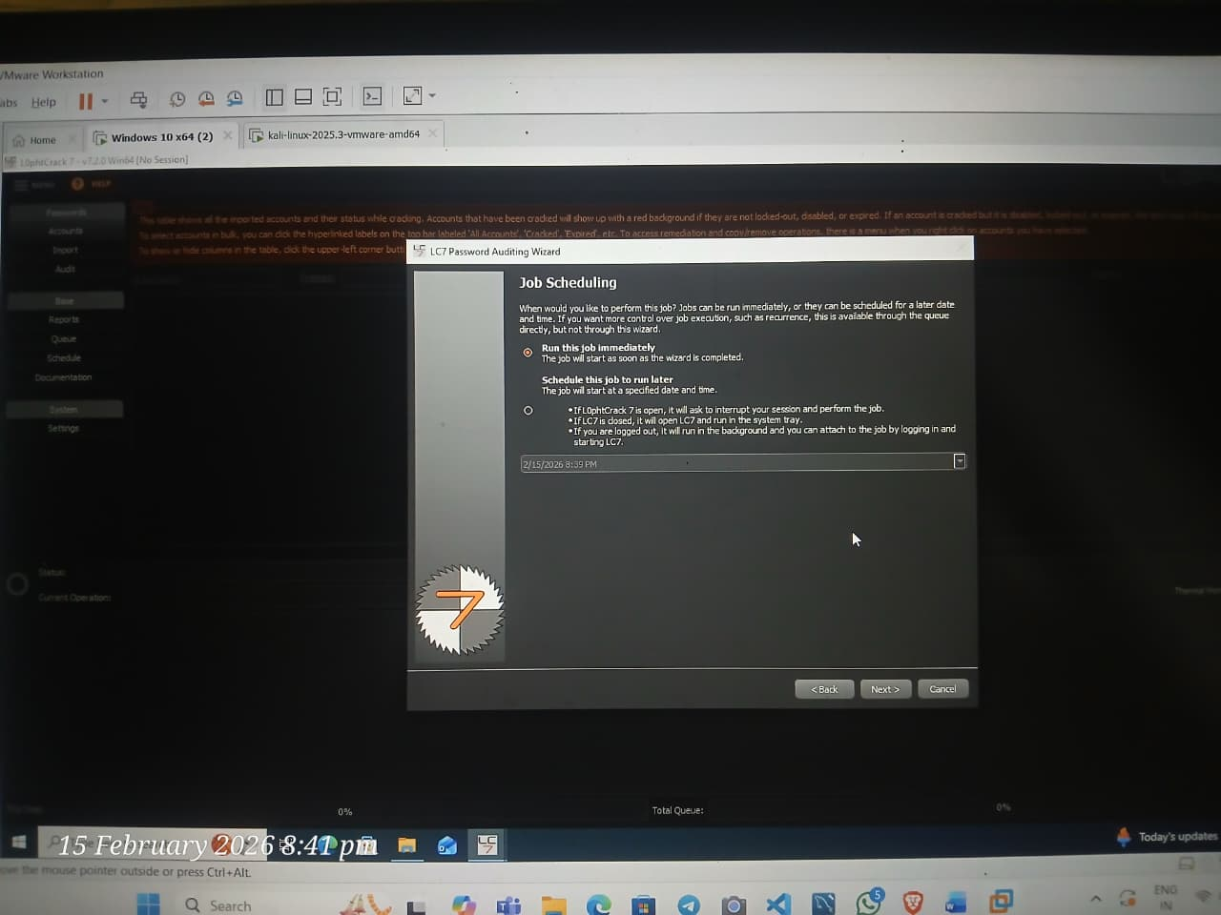
STEP11: Check the given details in the Summary wizard and click Finish.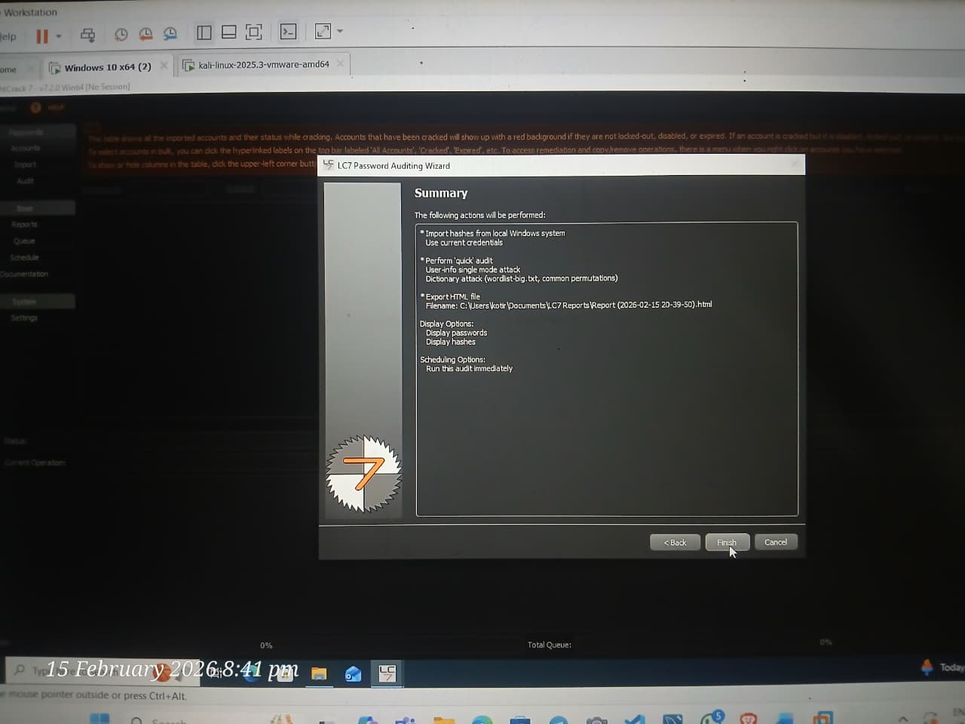
STEP12: L0phtCrack starts cracking the passwords of the LOCAL machine. In the lower-right corner of the window, you can see the status, as shown in the screenshot.
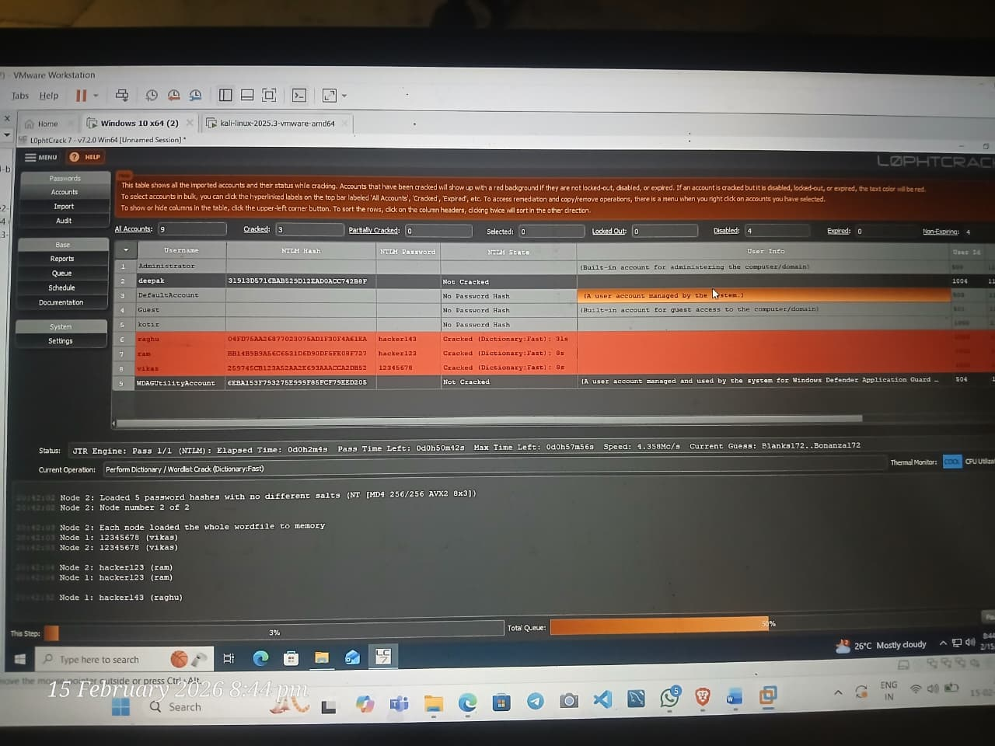
Step13: After successfully attaining weak and strong passwords, as shown in the screenshot, you can click the Stop button in the bottom-right corner of the window.

Emphasize the importance of strong password policies
*weak credentials policies cand lead to
- unauthorized system access
-data breaches
-privilege escalation.
Security recommandations:
-use 12 or 14 characters passwords.
-use upper/lowercase/,numbers/special&character.

